Student Name: Susmitha Challa
Student ID:15890964
Module Name: Machine Learning
Module Code:7072CEM

A Comparative Study of Machine Learning Algorithms for Detecting Fraudulent Online Shops Using URL-Based Features

Abstract— The rapid growth of E-commerce has led to an increase in fraudulent online shops designed to steal customer information. Traditional blacklist and rule-based detection methods often fail against such threats, as malicious URLs can closely mimic legitimate ones. This project employs URL-derived lexical and metadata features to identify fraudulent online shops using supervised machine learning. Three models—Random Forest, Support Vector Machine (SVM), and Logistic Regression—were trained and evaluated on a labeled dataset of legitimate and fraudulent URLs. Exploratory Data Analysis revealed distinguishing patterns such as higher digit counts, unusual top-level domains, younger domain ages, and missing or unverifiable contact details. Among the models tested, both SVM and Random Forest achieved the highest accuracy of approximately 92.6%, followed by Logistic Regression at 91.6%. The results demonstrate that combining lexical and metadata-based features is effective for accurately detecting fraudulent online shops.
Keywords Fraudulent online shops, Exploratory Data Analysis, Random Forest, Support Vector Machine, Logistic Regression, Phishing and malicious URL Detection.

INTRODUCTION

E-commerce's rapid growth has revolutionised worldwide retail by offering unparalleled ease, accessibility, and purchasing flexibility. Online shopping is becoming essential to modern digital life, with millions of transactions per day. Due to this boom, fraudulent e-commerce platforms that imitate legitimate stores have increased. Deceptive websites try to get users to provide personal information, pay false vendors, or download malicious malware. Cybercriminals constantly improve their approaches, making fraudulent websites look more legitimate, making manual detection measures useless. Scammers frequently change URL patterns and domain structures to avoid detection by blacklist- or rule-based systems, which fail to detect freshly emerging fraudulent URLs. This growing menace requires intelligent,
Automatic tools to detect fraudulent online shops.
Because it can evaluate complicated patterns in vast datasets, machine learning (ML) is one of the best methods for detecting malicious URLs. ML-based online fraud solutions have been studied for a decade. Vaishnavi et al. (2021) demonstrated the efficiency of traditional machine learning models, showing that Logistic Regression had a 97% accuracy rate in identifying malicious URLs. . Aljabri et al. (2022) identified key challenges in malicious URL detection algorithms, including uneven feature engineering, limited dataset diversity, and scalability limitations that inhibit real-world application. Further research enhances feature extraction methods. On several benchmark datasets, Jalil et al. (2022) revealed that Random Forest outperformed other models in encoding lexical URL patterns using TF-IDF. The importance of structural and lexical parameters, such as URL length, character composition, and domain repute, was highlighted by Jaswanthi et al. (2024), who discovered that the Extra Trees classifier outperformed other machine learning (ML) methods in accuracy. Hybrid and ensemble methods are common. A hybrid Logistic Regression, SVM, and Decision Tree model was developed by Karim et al. (2023) to improve robustness and prediction accuracy. According to Sánchez-Paniagua et al. (2025), the ELFW 2031 dataset, developed using XGBoost, included 50 novel engineering features with an F1-score above 96%. Hyperparameter optimisation gave Random Forest models 99.98% detection accuracy, citing Albishri and Dessouky (2024). In 2025, Kustiawan and Ghauth showed that CatBoost generates good feature sets using URL lexical features and HTML content. Recent works explore ML security and robustness beyond traditional ML. ML-based detectors are subject to URL changes; hence Sabir et al. (2022) recommend resilient models. Barik et al. (2025) achieved high accuracy using optimised CNN architectures trained on enormous malicious URL datasets and deep learning.
Following previous research, this study aims to create a simple and effective counterfeit online shop detection system using URL-derived numerical features. A computationally efficient and accurate real-time digital commerce fraud detection solution is found by comparing three traditional ML models—Logistic Regression, Random Forest, and Naive Bayes.

PROBLEM AND DATASET DESCRIPTION

E-commerce's rapid growth has transformed global retail, giving consumers unequalled convenience, accessibility, and product variety. However, fraudulent online stores that impersonate legitimate e-commerce platforms have increased due to this rapid expansion. Misleading URLs, professional-looking layouts, and faked product listings make these websites look like real online shops. They aim to trick unaware consumers into giving personal or financial information, paying for fake products, or installing malicious software. Manual inspection and traditional verification procedures are becoming less successful at detecting fraudulent platforms as fraudsters upgrade their approaches.
The continuously developing nature of online fraud has proven insufficient for conventional methods, including blacklist-based systems and rule-driven detection tools. Blacklists are swiftly outmoded since fraudulent domains are short-lived and constantly updated with new versions that bypass filters. Rule-based systems also fail because cybercriminals can evade specified URL patterns using unique domain structures, obfuscation tactics, or modified lexical features. The ever-changing world of fraudulent online shops requires clever, automated, and adaptable detection models that can recognize complicated patterns.

The present study leverages a publicly available dataset of tagged legitimate and fraudulent e-commerce URLs at this link to address these challenges:
https://www.google.com/url?q=https%3A%2F%2Fdata.mendeley.com%2Fdatasets%2Fm7xtkx7g5m%2F1
URL-derived numerical features capture lexical, statistical, and structural aspects such domain length, digit count, special characters, top-level domain type, and prefix usage. Engineered features let machine learning models distinguish between legitimate and fraudulent URLs in subtle but important ways. Tags for each entry indicate fraudulent or legitimate, making the dataset suitable for supervised classification. This research evaluates three machine learning models: Logistic Regression, Random Forest, and Support Vector Machine to develop a reliable and effective fraud detection system. The work uses URL-based features to build a lightweight, reliable classifier that can detect fraudulent online stores automatically and enhance digital commerce trust and safety.

METHODS
This work applies machine learning techniques to detect fraudulent online shops using numerical and lexical features extracted from URLs. The proposed model (Figure 1) follows a structured pipeline consisting of data collection, preprocessing, feature engineering, model training, and performance evaluation. The dataset contains labelled legitimate and fraudulent e-commerce URLs with attributes such as domain length, digit frequency, special characters, top-level domain category, and additional structural indicators of domain legitimacy. These features were selected because fraudulent websites often rely on irregular and randomly generated URL patterns, while legitimate sites follow consistent and recognizable naming rules.
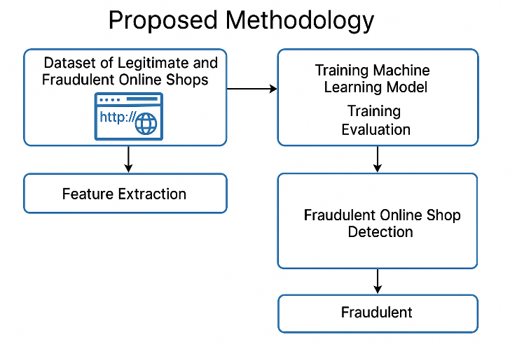
Figure 1 Proposed Model
Comprehensive preprocessing ensured that the dataset was consistent and ready for modelling. Missing values were resolved, class labels were verified, and categorical features were converted into numerical form to support machine learning algorithms. Standardization was applied to numerical attributes to maintain balanced influence during training. Outlier analysis helped differentiate genuine fraudulent behavior from noisy anomalies that could affect classification accuracy. Feature engineering further refined the dataset by identifying strong correlations, removing redundant variables, and highlighting the most informative attributes for detecting fraudulent URLs.

Classification was performed using three supervised learning algorithms: Logistic Regression (LR), Random Forest (RF), and Support Vector Machine (SVM). Logistic Regression provided an interpretable linear model, while Random Forest captured complex relationships through ensemble decision trees. SVM offered strong performance by identifying non-linear decision boundaries. Model performance was evaluated using confusion matrices, precision, recall, F1-score, and accuracy metrics. These evaluation measures assessed the effectiveness of each model in identifying fraudulent URLs while reducing misclassification, leading to a robust and reliable fraud-detection framework.

EXPERIMENTAL SETUP

The hardware, software environment, data preparation, model construction, and evaluation protocol used to develop and compare machine learning models for fraudulent online shop detection are described here.
A. Hardware/Software Environment
All experiments were carried out using Google Colab, a cloud-based environment with a virtual CPU and GPU. The implementation used Python 3.x and these important libraries: Data processing and numerical operations using pandas and NumPy preprocessing, model training, and evaluation with scikit-learn Visualization with matplotlib and seaborn SciPy adds statistical tools This environment allows researchers and practitioners to replicate experiments easily.
B. Dataset Preparation
Mendeley provided the Fraudulent Online Shops dataset. Panda DataFrame loaded CSV file. The number of instances, feature types, and class distribution (fraudulent vs. legitimate) had been verified first. Depending on their quantity and impact, missing or inconsistent values were addressed by imputation or elimination. Numeric types were assigned to all URL-derived feature columns, including length measures, character counts, and structural markers. The intended label was a binary variable: 1 = fraudulent, 0 = legitimate. All input features were standardized to zero mean and unit variance using StandardScaler to avoid scale dominance.
C. Split Training and Testing
The dataset was divided between training (75%) and testing (25%) subsets using stratified sampling based on class label to evaluate generalization performance. Classification maintains the original fraud-to-legitimate ratio in both sets, ensuring impartial evaluation of all models.
D. Model configuration
Three supervised machine learning models were used in this study. Logistic Regression (LR) served as a baseline linear classifier with L2 regularization to reduce overfitting and handle multicollinearity. Random Forest (RF), an ensemble of multiple decision trees, was applied to capture complex non-linear relationships and improve robustness through bootstrapped aggregation. Support Vector Machine (SVM) with an RBF kernel was employed to learn non-linear decision boundaries and maximize class separation. Default model parameters were used for all three algorithms, consistent with the project implementation, and each model was trained on the prepared training dataset before being evaluated on the test set.
E. Protocol Evaluation
All models were tested on the unknown test set after training. Using accuracy, precision, recall, F1-score, and confusion matrices, performance was measured. Bar charts of accuracy and confusion matrix heatmaps were also used to visually compare the results. This methodology allows consistent and thorough comparison of LR, RF, and SVM to find the best classifier for fraudulent online shop detection.

RESULTS

The desired variable distribution is examined first. The dataset is roughly balanced, with slightly more fraudulent websites than legitimate ones, as shown in Figure 2. This balanced distribution is suitable for supervised machine learning because it reduces majority class bias and improves predicted reliability.

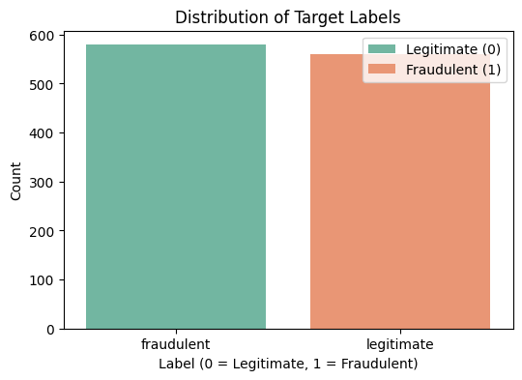
Figure 2 Distribution of Target Labels
Multiple feature-wise comparisons using boxplots were used to investigate how URL-based features differ between fraudulent and legitimate websites (Figure 3). Behavioural patterns across important URL features are seen in Figure 2. Fraudulent websites have slightly longer domain lengths and more irregularity. Top-domain length varies, with fraudulent sites using shorter or uncommon top-level domains. The "www" prefix is essentially identical in both classes, demonstrating that it is not a discriminative feature. In fraudulent URLs, the number of digits is higher because random numeric strings are used to look legitimate. Legitimate URLs are more structured and meaningful. The number of dots on legitimate websites is higher, which is consistent with hierarchical domain architecture employed by established businesses.

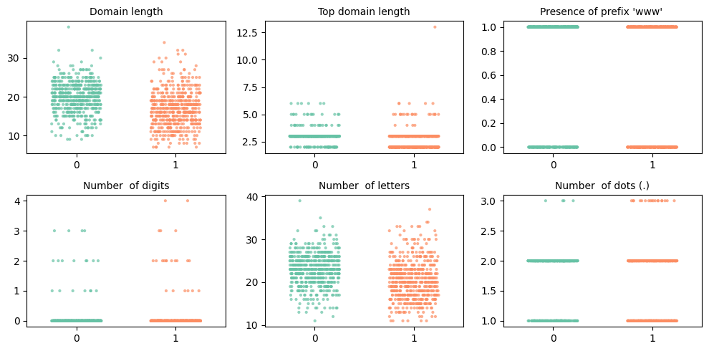
Figure 3 Multi-Feature URL Behavior Comparison

Correlation analysis illuminated feature linkages. The two classes have different patterns in Figures 4 and 5. In legitimate websites, trust-related metadata such as SSL provider, TrustPilot presence, and Tranco rank show stronger correlations with legitimacy-indicating features. On the other hand, fraudulent websites show stronger correlations with attributes like young domain indication and the presence of free or missing contact information, which are scam websites red flags. Most URL features in both heatmaps have weak-to-moderate correlations, demonstrating their unique and complementary classification information.
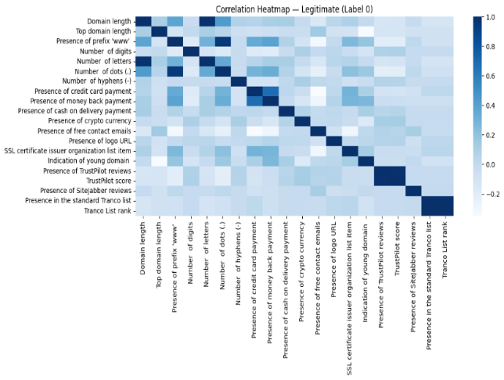
Figure 4 Correlation Heatmap for Legitimate Website

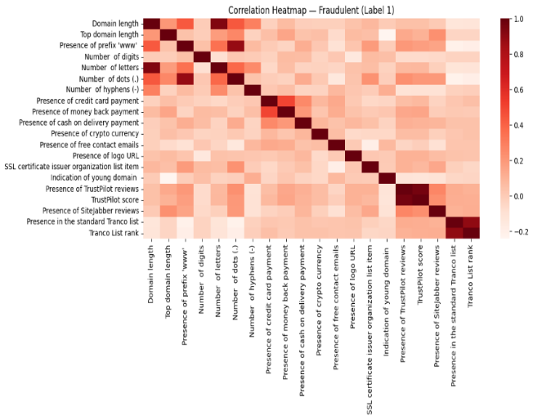
Figure 5 Correlation Heatmap for Fraudulent Websites

Figure 6 compares the accuracy of three machine-learning algorithms used for classifying fraudulent and legitimate online shops. Logistic Regression shows strong performance at about 91.6%, while both SVM (RBF) and Random Forest achieve higher and identical accuracies of about 92.6%. The figure highlights that ensemble and kernel-based methods slightly outperform linear models for this dataset.

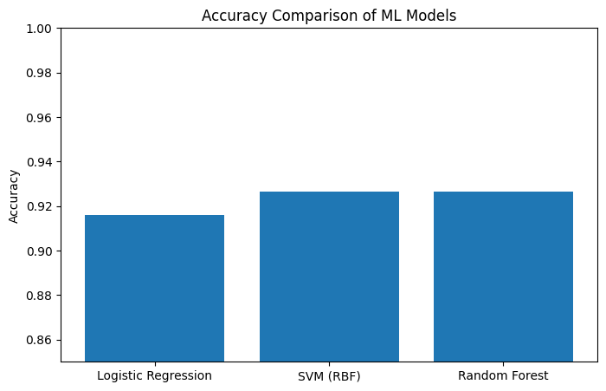
Figure 6 Performance Comparison of ML Models
Overall, URL features and trust-based information significantly improve fraudulent website detection. The investigation validates that domain age, external review credibility, and feature URLs play key roles in identifying fraudulent sites from legitimate ones.

DISCUSSION AND CONCLUSION

This study demonstrates that URL-based lexical and metadata features are essential for distinguishing fraudulent online shops from legitimate ones. Exploratory analysis and model interpretation reveal that structural URL attributes—such as domain length, digit frequency, special characters, and top-level domain type—provide meaningful signals but are not sufficient on their own for highly accurate fraud detection. Fraudulent websites often imitate conventional URL patterns to appear credible, reducing the reliability of surface-level URL characteristics.
Correlation heatmaps and feature importance rankings highlight deeper behavioural indicators of fraud, such as younger domain age, irregular registration patterns, and missing or inconsistent metadata. Consistent with cybersecurity research, fraudulent domains are frequently

newly registered or short-lived, allowing attackers to evade long-term monitoring. These observations reinforce the need for multi-layered feature engineering rather than relying solely on simple lexical features.
Supervised learning models—Logistic Regression, Random Forest, and SVM—were applied to classify URLs based on these engineered features. Random Forest and SVM achieved the highest accuracy, effectively capturing both linear and non-linear patterns in the dataset. Despite strong performance, certain challenges remain, as fraudsters continue evolving techniques to mimic legitimate URL structures. Features like “www” presence or overall URL length show limited discriminative value, suggesting the need for richer contextual indicators.
Future work should incorporate additional signals such as hosting information, DNS records, IP reputation, SSL certificate attributes, and behavioural analytics to enhance model robustness. Expanding the dataset and updating features dynamically will further strengthen the adaptability and reliability of fraudulent shop detection systems.

REFERENCES

Abey, J. S., Mathew, S., George, T. P., Eapen, N. M., Cheriyan, J., & Pattani, R. V. (2025). Advanced Malicious URL Detection using Machine Learning. IEEE,504–509. https://doi.org/10.1109/access65134.2025.1113583
Albishri, A. A., & Dessouky, M. M. (2024). A comparative analysis of machine learning techniques for URL phishing detection. Engineering Technology & Applied Science Research, 14(6), 18495–18501. https://doi.org/10.48084/etasr.8920
Aljabri, M., Altamimi, H. S., Albelali, S. A., Al-Harbi, M., Alhuraib, H. T., Alotaibi, N. K., Alahmadi, A. A., Alhaidari, F., Mohammad, R. M. A., & Salah, K. (2022). Detecting malicious URLs using Machine Learning Techniques: Review and research directions. IEEE Access, 10, 121395–121417. https://doi.org/10.1109/access.2022.3222307
Barik, K., Misra, S., & Mohan, R. (2025). Web-based phishing URL detection model using deep learning optimization techniques. International Journal of Data Science and Analytics, 20(5), 4449–4471. https://doi.org/10.1007/s41060-025-00728-9
Jalil, S., Usman, M., & Fong, A. (2022). Highly accurate phishing URL detection based on machine learning. Journal of Ambient Intelligence and Humanized Computing, 14(7), 9233–9251. https://doi.org/10.1007/s12652-022-04426-3
Jaswanthi, T., Harshitha, T., Tanya, S., & Belwal, M. (2024). Malicious URL Detection: Comparative Study of Machine Learning Algorithms. IEEE, 1–5. https://doi.org/10.1109/icccnt61001.2024.10725561
Kailas, S., & Roopalakshmi, R. (2025). “Think Before You Click”—Malicious URL Detection in Cybersecurity: A Systematic Review and Research Roadmap. IEEE Access, 13, 154305–154325. https://doi.org/10.1109/access.2025.3601387
Karim, A., Shahroz, M., Mustofa, K., Belhaouari, S. B., & Joga, S. R. K. (2023). Phishing detection system through hybrid machine learning based on URL. IEEE Access, 11, 36805–36822. https://doi.org/10.1109/access.2023.3252366
Kustiawan, Y. A., & Ghauth, K. I. (2025). Evaluating the Impact of feature engineering in phishing URL detection: A comparative study of URL, HTML, and derived features. IEEE Access, 13,126756–126768. https://doi.org/10.1109/access.2025.3579223
Mohanty, S., & Acharya, A. A. (2025). Detection of Cyber Attacks from Malicious URLs Using Ensemble Machine Learning Techniques. In Studies in computational intelligence (pp. 55–87). https://doi.org/10.1007/978-981-96-5585-4_3
Nair, A., Patel, P., Vadher, H., Patel, M., Vyas, T., Bhatt, C., Conte, L., & De Nunzio, G. (2025). Securing healthcare systems: a random forest approach to malicious URL detection. Journal of Computer Virology and Hacking Techniques, 21(1). https://doi.org/10.1007/s11416-025-00579-9
Sabir, B., Babar, M. A., Gaire, R., & Abuadbba, A. (2022). Reliability and Robustness analysis of Machine Learning based Phishing URL Detectors. IEEE Transactions on Dependable and Secure Computing,1–18. https://doi.org/10.1109/tdsc.2022.3218043
Sánchez-Paniagua, M., Fidalgo, E., Alegre, E., & Jáñez-Martino, F. (2025). Fraud detection in e-commerce: a comparative analysis of features to enhance machine learning models. Electronic Commerce Research. https://doi.org/10.1007/s10660-025-10029-9
Sivakumar, C., Sagar, P. L., Swetha, K., Raju, K. A., Kumar, G. N., & Nanditha, M. N. (2025). Detecting Malicious URLs using Machine Learning. IEEE, 605–612. https://doi.org/10.1109/icoeca66273.2025.00110
Tian, Y., Yu, Y., Sun, J., & Wang, Y. (2025). From Past to Present: A survey of malicious URL detection techniques, datasets and code repositories. arXiv(CornellUniversity)https://doi.org/10.48550/arxiv.2504.16449
Vaishnavi, D., Suwetha, S., Jinila, Y., Subhashini, R., & Shyry, S. (2021). A Comparative Analysis of Machine Learning Algorithms on Malicious URL Prediction. IEEE, 8, 1398–1402. https://doi.org/10.1109/iciccs51141.2021.9432138

APPENDIX
